

Mitchell School of Music

User Guide



This document has been created for the sole purpose of assisting Mitchell School of Music employees with using their new admissions system. It has been separated by section an includes a contents page for ease of navigation.

Contents page:

Log In

The first screen you will be presented with once the application has loaded will be the sign in page. Ask the administrator to create an account for you. Until then, the temporary credentials Username: “TestUser” and password: “TestPassword” will work fine. Enter these into the respective text boxes seen on screen and click the log in button to be presented with the rest of the application

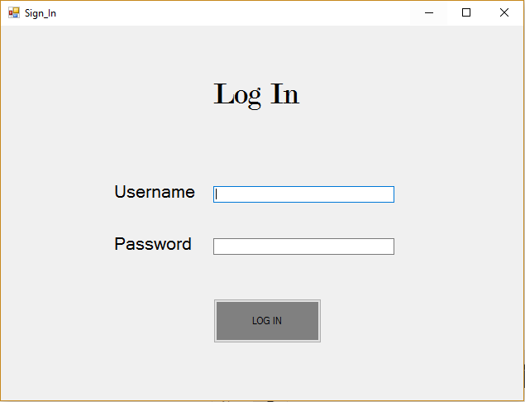

Main Menu:

Following this, you will be presented with the main menu of the application. The four main areas of the application are shown, however clicking any of the areas outside of the rental system will prompt you with a maintenance error, as those particular functions aren’t being developed by me. If Once they are developed though, they may be linked and then accessed through these buttons which accommodate future expansion for the admissions system.

For the time being however, the ‘Instrument Rental’ section is where most of the applications functionality currently resides. Left clicking the right hand side button in the group box will bring you to the form used to view the data available from the database, whilst the left hand side button will bring you to the form used to add new records to existing tables. You may also use the “Add User” menu strip item along the top of the screen to create new users and add new log in credentials to the system to accommodate new employees.

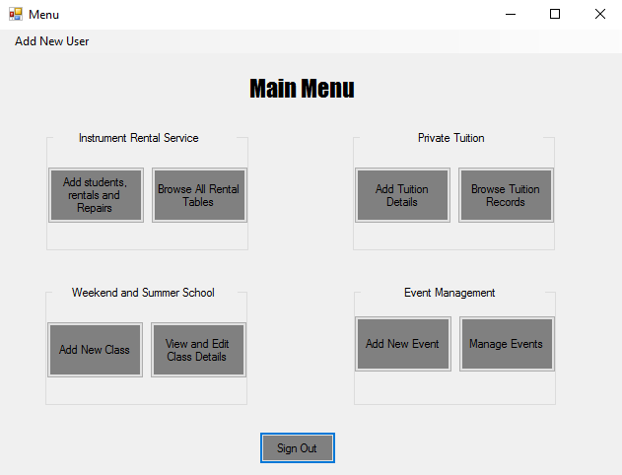

Clicking this brings you to the ‘Add New User’ form, which allows you to sign new users up

Clicking this brings you to the ‘Add Students, Rentals and Repairs’ form, where you can add new records to the database

Clicking this brings you to the ‘View All Rental Tables form, where you can view database records

Clicking this brings you to the ‘Sign In’ form, signing you out in the process and protecting the program from unauthorised access once you leave your work station.

Add Form

**Add Student Tab**